AWS Pricing

AWS offers you a pay-as-you-go approach for pricing for over 200 cloud services. With AWS you pay only for the individual services you need, for as long as you use them, and without requiring long-term contracts or complex licensing. AWS pricing is similar to how you pay for utilities like water and electricity. You only pay for the services you consume, and once you stop using them, there are no additional costs or termination fees.

Find out how much you could be saving in the AWS Cloud with the [AWS Pricing Calculator](https://calculator.aws/?ch=cta&cta=-lower-editorial-pricing-calc).

How do you pay for AWS?

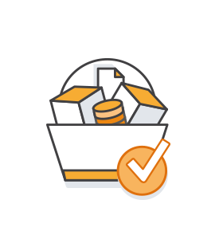

Pay-as-you-go

Pay-as-you-go allows you to easily adapt to changing business needs without overcommitting budgets and improving your responsiveness to changes. With a pay-as-you-go model, you can adapt your business depending on need and not on forecasts, reducing the risk of overprovisioning or missing capacity.

[Read more »](https://aws.amazon.com/pricing/)

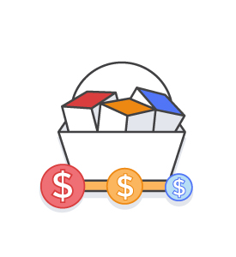

Save when you commit

For AWS Compute and AWS Machine Learning, Savings Plans offer savings over On-Demand in exchange for a commitment to use a specific amount (measured in $/hour) of an AWS service or a category of services, for a one- or three-year period.

[Read more »](https://aws.amazon.com/pricing/)



Pay less by using more

With AWS, you can get volume based discounts and realize important savings as your usage increases. For services such as S3, pricing is tiered, meaning the more you use, the less you pay per GB. AWS also gives you options to acquire services that help you address your business needs.